Test and Trace Process for Educational Settings
This guidance document and flowchart have been produced for educational settings to guide them through Test and Trace. This flowchart replaces all previous versions. You should now follow the process outlined below and illustrated in the flowchart.
The main changes from the last flowchart are:
- We no longer ask educational settings to report suspected cases of COVID-19 to us in the way that they were doing previously. There is no need for settings to email or ring their NYCC contacts. We will receive information about suspected cases from the daily return to the DfE that settings complete.
- There is a new process for educational settings to report positive cases (staff or children/young people).
- NYCC contact numbers and other reporting details have changed.
FROM THE 18TH OF SEPTEMBER 2020, YOU NEED TO FOLLOW THE FOLLOWING STEPS:
- Anyone who experiences symptoms (new, persistent cough and/or high temperature and/or a change/loss in the sense of smell or taste) is advised to self-isolate and order a test. Anyone in the household will also need to self-isolate (including children if parents are symptomatic).
- A test can be requested from the NHS website or by ringing 119.
- Whilst the person with symptoms is self-isolating and waiting for their test result, there is no need for any additional measures to be taken by the educational setting, except to ensure hand and environmental hygiene measures are in place.
- If the test comes back negative, then the person can return to the setting (provided they feel well enough). Please note, if a person is a contact of a COVID positive case, they need to complete the 14-day isolation period regardless of whether they get a negative test result in those 14 days. The rest of their household (e.g. siblings) can still attend school provided the person is not symptomatic.
- If a test comes back as inconclusive, then another test needs to be arranged. Whilst a result is expected, the person waiting for the test needs to stay at home and not attend the setting.
- If a test comes back positive, educational settings need to ring the new DfE helpline (0800 046 8687) and select Option 1 for advice on the action to take. If, following triage, further expert advice is required, the adviser will escalate the call to the local health protection team (HPT).
- The DfE advisers will help settings identify any close contacts of the positive case and advise on further actions.
- Following the call to the DfE, settings are asked to inform NYCC of the fact that there is a positive case. To report this, settings need to ring 01609 780 780 and select Option 3.
- In the case that a setting has 2 or more positive cases, the local Health Protection Team (Public Health England) needs to be notified immediately on 0113 386 0300 (9-5 Mon-Fri) or 0151 909 1219 (out of hours). The local authority will also need to be informed (01609 780 780 and select Option 3) after the Health Protection Team has been notified.
- In circumstances where settings don’t have any confirmed cases but require advice and/or having difficulties getting through to the DfE helpline or the Health Protection Team, NYCC should be contacted on 01609 780 780 and select Option 3.
The flowchart below sets out the steps described above, an easy guide to what educational settings need to do should a staff member or child/young person develops COVID-19 symptoms.
Please note that the guidance is still evolving nationally so our approach may be updated.

Staff or children/young people with COVID-19 symptoms (new cough and/or high temperature and/or a change/loss in sense of smell or taste) are asked to self-isolate and order a test.

If a parent tests positive, their child/ren need to isolate for 14 days. The setting doesn’t need to take any action.
A test can be requested from the NHS website or by ringing 119.
Schools have also been given 10 test kits which they can use at their discretion.

Report suspected cases in your DfE daily return which is shared with NYCC automatically

Once you know the outcome of the test

Inconclusive test
Negative test

Positive test
Ring the DfE helpline (0800 046 8687 Option 1) for advice and further actions
Relevant staff/children return to the setting.
Staff/children who are contacts of a COVID positive case need to complete 14 days of self-isolation regardless of whether they test negative in that time. The rest of their household (e.g. siblings) can still attend school provided the person is not symptomatic.
Ask for another test; the person needs to stay at home. No further action needed by the setting until a result is received.

After speaking to the DfE advisers, inform NYCC on 01609 780 780 and select Option 3.

If you have 2 or more positive cases in your setting, you need to notify the Health Protection Team (Public Health England):
0113 386 0300 (9-5 Mon-Fri)
0151 909 1219 (out of hours)

Please note:
In the case of an outbreak (2 or more positive cases in the setting within 14 days), the Health Protection Team, the local authority Public Health leads, CYPS colleagues and the setting will work together to manage the outbreak.

After speaking to the Health Protection Team, inform NYCC on 01609 780 780 and select Option 3.

Useful Links:

- CYPS Info
- Guidance for full opening: schools
- Guidance for full opening: special schools and other specialist settings
- Actions for early years and childcare providers during the coronavirus (COVID-19) outbreak
- Face coverings in education
- Transport to school and other places of education: autumn term 2020
- Guidance for contacts of people with possible or confirmed coronavirus (COVID-19) infection who do not live with the person
- NHS Test and Trace: how it works
- NHS test and trace: workplace guidance

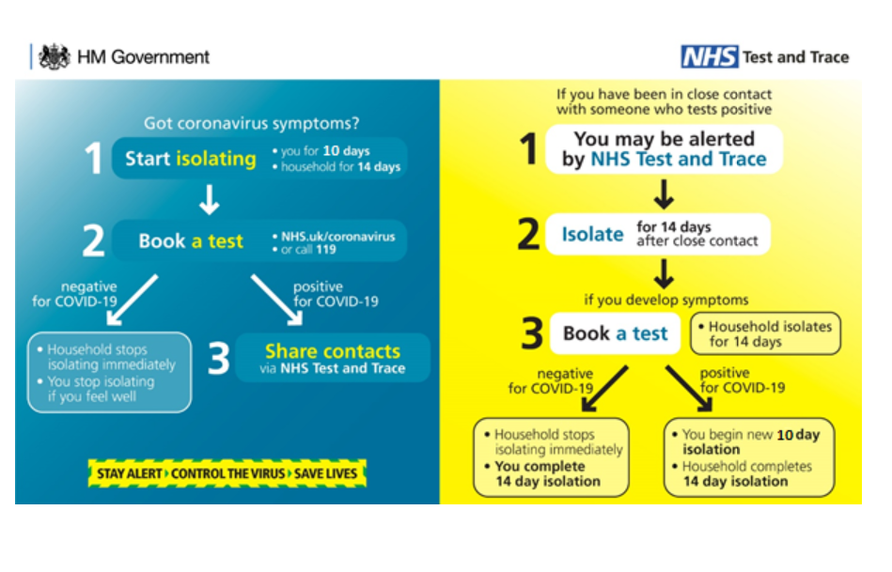

Useful contacts:
NYCC: 01609 780 780, select Option 3 (Mon- Thurs 8am -5.30pm, Fri 8am – 4.30pm)
DfE helpline: 0800 046 8687
Yorkshire and Humber Health Protection Team: 0113 386 0300 (9-5 Mon-Fri) or 0151 909 1219 (out of hours)

