Great North Road,
Fairburn,
Knottingley,
West Yorkshire.
WF11 9JY.

Tel\Fax 01977 672158

E-mail: admin@fairburn.n-yorks.sch.uk

Head teacher: Mrs Emma Cornhill.

6th July 2022

Dear Parents,

We would like to inform you that from September we will be using Parent Pay as an online system where you can pay for all school expenses through using a debit/credit card. This is in response to the many parents who have requested an online payment system as well as higher pupil numbers enabling this to now be cost effective.

What are the benefits to parents & pupils? | What are the benefits to our school?
ParentPay is easy-to-use and will offer you the freedom to make online payments whenever and wherever you like, 24/7  The technology used is of the highest internet security available ensuring that your money will reach school safely – offering you peace of mind  Payments can be made by credit/debit card  Full payment histories, balance alerts and statements are available to you securely online at anytime | You can help us reduce workloads for all staff as no more counting cash, chasing debt and stop cash collection services  Creates more time to lend to educational support and the smooth running of the school  Improves school security  Using ParentPay also ensures that all financial transactions are safe and secure - helping us to remove costs associated with us having to manage cash securely on the school premises  The more parents that use ParentPay, the greater the benefit is to our school.

How to get started with ParentPay?

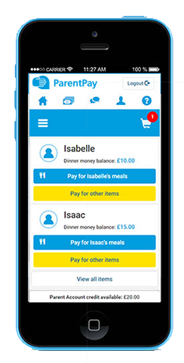
We will send you your account activation details in September. Once you receive these:
Visit www.parentpay.com

Enter your Activation username and password in the Account Login section of the homepage
NB. These are for one-time use only, please choose your own username and password for future access during the activation process

Provide all the necessary information and choose your new username
and password for your account - registering your email address will enable us to send you receipts and reminders

Once activation is complete you can go straight to Items for payment, select which item(s) you want to add to your basket and proceed to complete your payment
If you have any questions, please contact the school office. For more information, visit www.parentpay.com/parents/

Yours Faithfully

Emma Cornhill
Head Teacher

