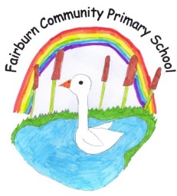
Great North Road,
Fairburn,
Knottingley,
West Yorkshire.
WF11 9JY.

Tel\Fax 01977 672158

E-mail: admin@fairburn.n-yorks.sch.uk

Head teacher: Mrs Emma Cornhill.

14th November 2022
Dear Parents,

We are delighted to let you know that on Thursday 8th December 2022 we have booked to take the children on our annual visit to Harrogate Theatre to see the pantomime “Aladdin”.

This is very exciting as we have not been able to run this trip since Covid so it is lovely to be able to take the children back to the theatre.

The children will be accompanied by staff and will travel to Harrogate by coach leaving promptly at 12:30pm.
As our numbers of children are now 88, we have needed to book 2 coaches to take us all.

The total cost of the transport is £800 and theatre tickets are £12 per child which is a total cost of £21 per child. We are therefore asking for a voluntary donation of £18 per child towards the cost of this visit.

The children will be given a snack by the school in the interval and will have eaten their lunch before we go. School uniform should be worn for this visit.

The performance is due to end by 4:30pm so we expect to arrive back at school at approximately 5:15pm depending on the traffic.

This item is available on Parent Pay and please tick the consent box on there to give permission for your child to attend. We will be making this a trip that you can pay in instalments on Parent Pay.
If you are worried about the cost, please either call into the office or email support@fairburn.org.uk

If you have any queries or concerns, please do not hesitate to see either myself or Mrs McCrory.
Yours faithfully

Mrs Emma Cornhill
Head Teacher

