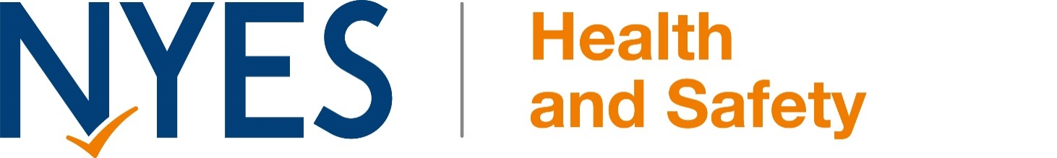
COVID-19 OUTBREAK MANAGEMENT PLAN

Fairburn C P School

General Statement
This plan is based on the contingency framework for managing local outbreaks of COVID-19 and the schools operational guidance, provided by the Department for Education (DfE).
We will only implement some, or all, of the measures in this plan in response to recommendations provided by our local authority, directors of public health, Public Health England health protection team or the national government.
It may be necessary to implement these measures in the following circumstances, for example:
To help manage a COVID-19 outbreak within the school. Actions will be considered when either of the following thresholds are met:
[For most settings, use:]
There are 5 positive cases amongst pupils or staff who are likely to have mixed closely within a 10-day period;
10% of pupils or staff who are likely to have mixed closely test positive within a 10-day period;

If COVID-19 infection rates in the community are extremely high, and other measures have failed to reduce transmission;
As part of a package of measures responding to a ‘variant of concern’;
To prevent unsustainable pressure on the NHS.
Seeking Public Health Advice
When one of the thresholds above is met, we will review the testing, hygiene and ventilation measures already in place.
We will also seek public health advice from a director of public health or health protection team. Emma Cornhill/ Claire McCrory will be responsible for seeking this advice, and will do so by telephoning the DfE helpline (0800 046 8687)
Shielding
We will adhere to national guidance on the reintroduction of shielding, which would apply to those on the shielded patient list (SPL).
We will speak to individuals required to shield about additional protective measures in school or arrangements for home working or learning.

Other Measures
Parents, carers, pupils and staff will be informed promptly about the introduction of control measures. This will be done via email/letters sent home with pupils once a decision has been made.
If recommended, we will limit:
Residential educational visits;
Open days;
Transition or taster days;
Parents coming into school;
Live performances.

If recommended, we will (re)introduce:
Bubbles, to reduce mixing between groups;
Face coverings in communal areas and classrooms for staff and visitors (unless exempt).
Attendance Restrictions
Attendance restrictions will only be implemented as a last resort. If recommended, we will implement the measures in this section.
Eligibility to remain in school
If restrictions are recommended, we will stay open for vulnerable pupils and children of critical workers.
Education and support for pupils at home
All other pupils will be required to stay at home and will receive remote education.
We will aim to deliver remote education that meets the same quality and quantity of education that pupils would receive in school, as outlined in our remote learning policy on our website.
The school will continue to provide meals or lunch parcels for pupils eligible for benefits-related free school meals while they are not attending school because of COVID-19 isolation guidelines.
Parents are given the option of either collecting meals from school or having a meal voucher.
Wraparound care
We will limit access to before and after-school activities and wraparound care during term time and the summer holidays to those that need it most.
We will communicate who will be eligible to attend once the restrictions are confirmed.
Safeguarding
We will review our child protection policy to make sure it reflects the local restrictions and remains effective.
We will aim to have a trained DSL or deputy DSL on site wherever possible.
If our DSL (or deputy) can’t be on site, they can be contacted remotely by through the school office.
If our DSL (or deputy) is unavailable, we will share a DSL with Burton Salmon Primary School. Their DSL can be contacted by through their school office.
On occasions where there is no DSL or deputy on site, a senior leader will take responsibility for co-ordinating safeguarding on site.
When vulnerable pupils are absent, we will:
Speak to parents/carers and, where applicable, social workers and the local authority, to work out the reason for absence;
Encourage attendance;
Make sure vulnerable pupils can access appropriate education and support while at home;
Maintain contact, and check regularly that the pupil is able to access remote education provision.

Signed: | 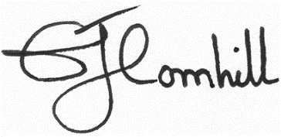
Date: | 10/9/21
Review Date: | December 2021 or sooner dependent on the National situation.

