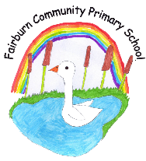

Fairburn Community Primary School Governing Board

Schedule of Governing Board & Committee Meetings and Other Governance Activities 2023-2024

Month → | Sept. | Oct. | Nov. | Dec. | Jan. | Feb. | Mar. | Apr. | May | Jun. | Jul.
Full Governing Board  (4 + 1 as required) | Thurs.  12  October  6.45pm |  |  | Thurs.  14 December  6.45pm |  |  | Wedn.  20  March  6.45pm |  | Budget Approval meeting  Wedn.  22  May  [online] |  | Thurs.  4  July  6.45pm
Committees
Finance and Resources  (3 + 1 as required) |  |  | Tues  21 Nov  9.30am |  |  |  | Tues  12 March  9.30am |  | Thurs.  17 May  9.30am |  | Tues  25 Jun  9.30am
Strategic Core Values  Session |  |  |  |  | Thurs  25  January  7pm
HT Performance Management |  |  |  |  | Wedn  10  Jan

