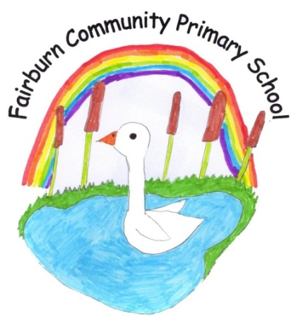
Great North Road,
Fairburn,
Knottingley,
West Yorkshire.
WF11 9JY.

Tel\Fax 01977 672158

E-mail: admin@fairburn.n-yorks.sch.uk

Head teacher: Mrs Emma Cornhill.
4Th June 2023

Dear Parent,

We are pleased to say we are able to have the whole school participate in Forest School days again this year.

A Forest School approach is defined as:
‘An inspirational process that offers children regular opportunities to achieve, develop confidence and self esteem through hands on learning experiences in a local woodland environment, school grounds or local park’. (Developing a Forest School in EY provision.)

We work with a specialist consultant in this area and we will be jointly delivering a series of outdoor sessions starting next week at Bishop Wood, Cawood. All children will be continuing to work towards completing the ‘Wild Passport Challenges’ as they have in previous years.

Please see the dates below-

Class | Dates | Time
Two- Y4/5/6 | 7th June | Full day- 9.30-2.30pm
 | 14th June | Full day
 | 21st June | Full day
Class 1- Y2/3 | 6th June | Full day
 | 13th June | Full day
 | 20th June | Full day
Foundation/Y1 | 5th June | Full days- 9.30- 2.30pm
 | 12th June | Full day
 | 19th June | Half day- pm session
 | 3rd July | Full day
 | 10th July | Full day
 | 17th July | Full day

If your child is at Forest School for a full day, they will be provided with a packed lunch unless they usually bring their own to school.
Your child will need long trousers/ joggers/ leggings, a long-sleeved t-shirt, a sweatshirt, a waterproof coat and wellies to protect them from the elements. Your child is advised to wear a long sleeved top even in hot weather as well as have covered legs.

Please can all children have sun cream on before they go to Forest School sessions so that we can top it up around mid- day, weather depending.
Can all children also have insect repellent on as they are in an environment where there will be lost of midges. We will issue all children with a Deet free bracelet to wear too.

A full Risk Assessment has been carried out which you are welcome to see on request.

We think this will then add another element to our curriculum which will help build the children’s confidence, enable them to learn in the great outdoors and to enjoy being in the natural environment around them.

If you have any questions, please pop in and have a chat with either Miss Dent, Miss Ferguson or Mrs Clague.

Yours faithfully

Mrs Emma Cornhill
Head Teacher

