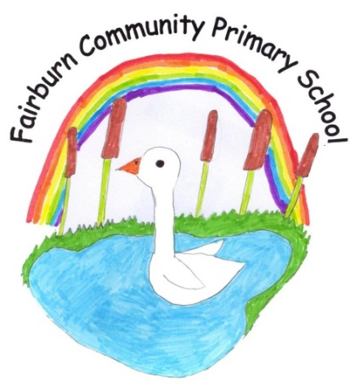
Great North Road,
Fairburn,
Knottingley,
West Yorkshire.
WF11 9JY.

Tel\Fax 01977 672158

E-mail: admin@fairburn.n-yorks.sch.uk

Head teacher: Mrs Emma Cornhill.
4th April 2022

Dear Parent,

We are pleased to say we are able to have the whole school participate in Forest School days again this year.

A Forest School approach is defined as:
‘An inspirational process that offers children regular opportunities to achieve, develop confidence and self esteem through hands on learning experiences in a local woodland environment, school grounds or local park’. (Developing a Forest School in EY provision.)

We work with a specialist consultant in this area and we will be jointly delivering a series of outdoor sessions starting next week at Bishop Wood, Cawood.

Please see the dates below-

Class | Dates | Time
Two- Y4/5/6 | 7th April | Whole day- 9.30-2.30pm
 | 28th April | Whole day
 | 22nd June | Whole day
Class 1- Y2/3 | 29th April | Half days- 9.30-11.30am
 | 6th May
 | 20th May
 | 27th May
 | 10th June
 | 24th June
Foundation/Y1 | 27th April | Full days- 9.30- 2.30pm
 | 4th May
 | 25th May
 | 8th June
 | 23rd June
 | 6th July

If your child is at Forest School for a full day, they will be provided with a packed lunch unless they usually bring their own to school.
Your child will need jeans/ joggers, a long-sleeved t-shirt, a sweatshirt, a waterproof coat and wellies to protect them from the elements.

A full Risk Assessment has been carried out which you are welcome to see on request.

We think this will then add another element to our curriculum which will help build the children’s confidence, enable them to learn in the great outdoors and to enjoy being in the natural environment around them.

If you have any questions, please pop in and have a chat with either Mr Wynne, Miss Grimshaw/Mrs Boldy or Mrs Clague.

Yours faithfully

Mrs Emma Cornhill
Head Teacher

