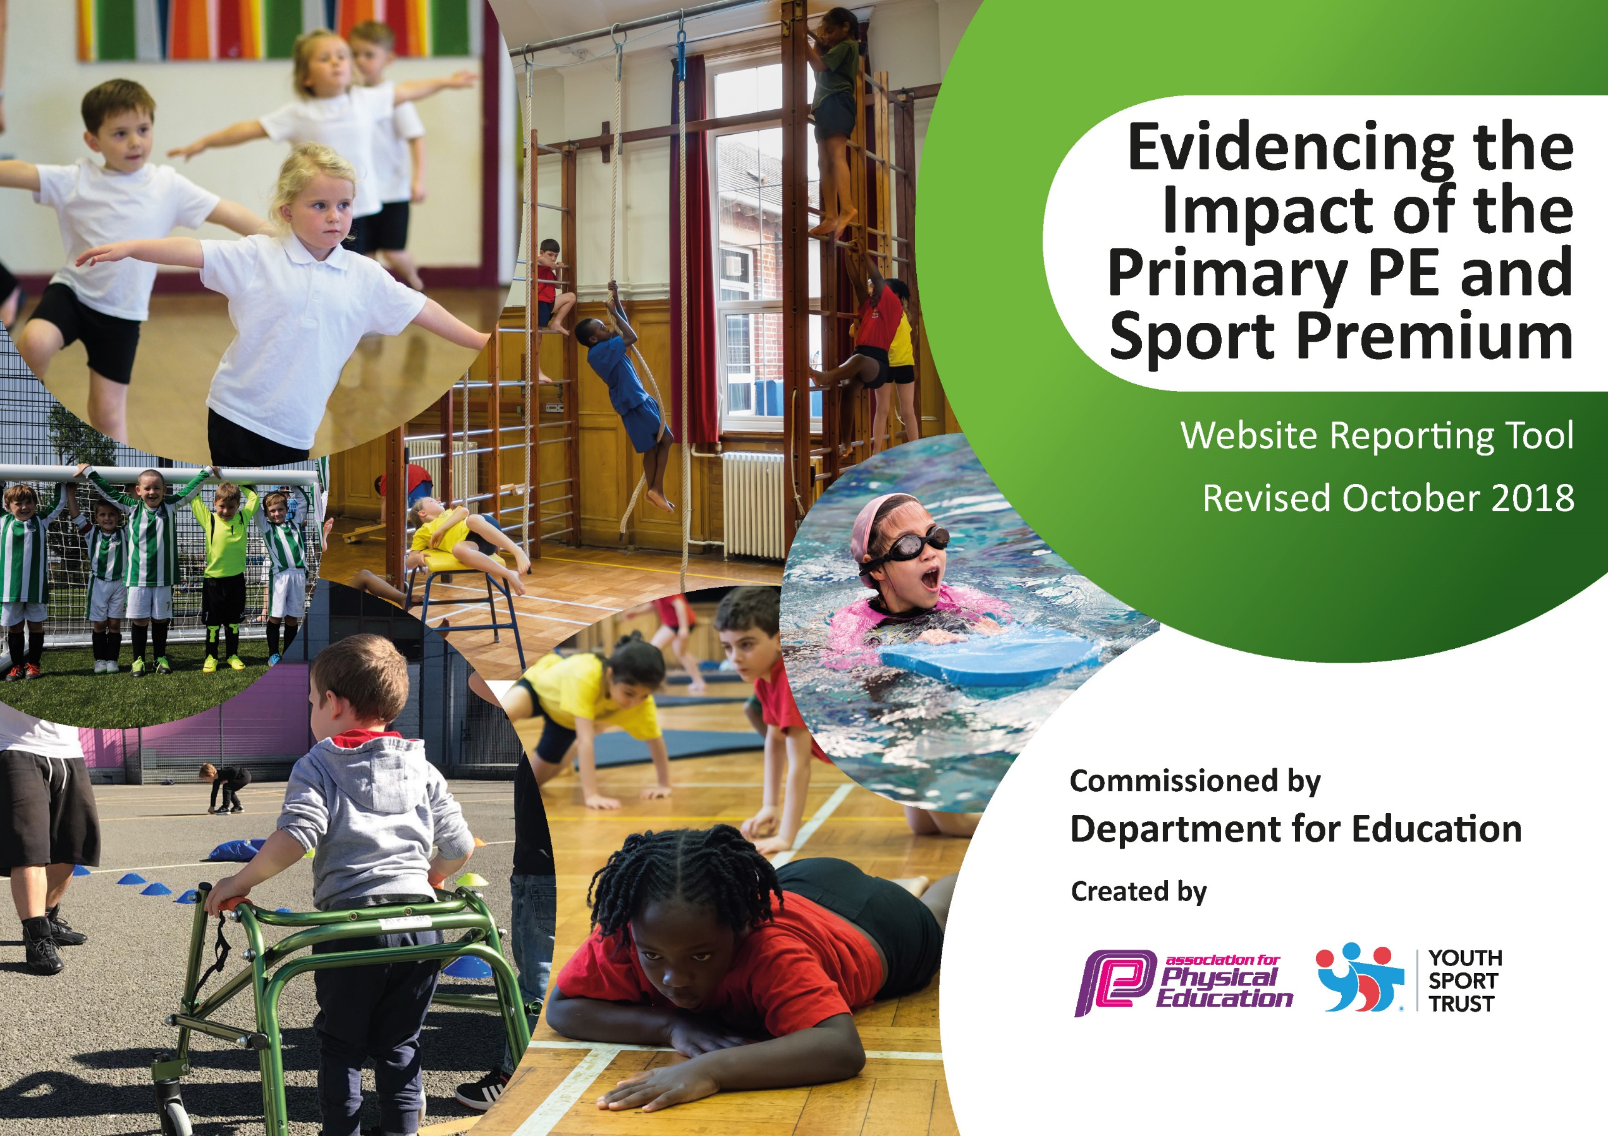
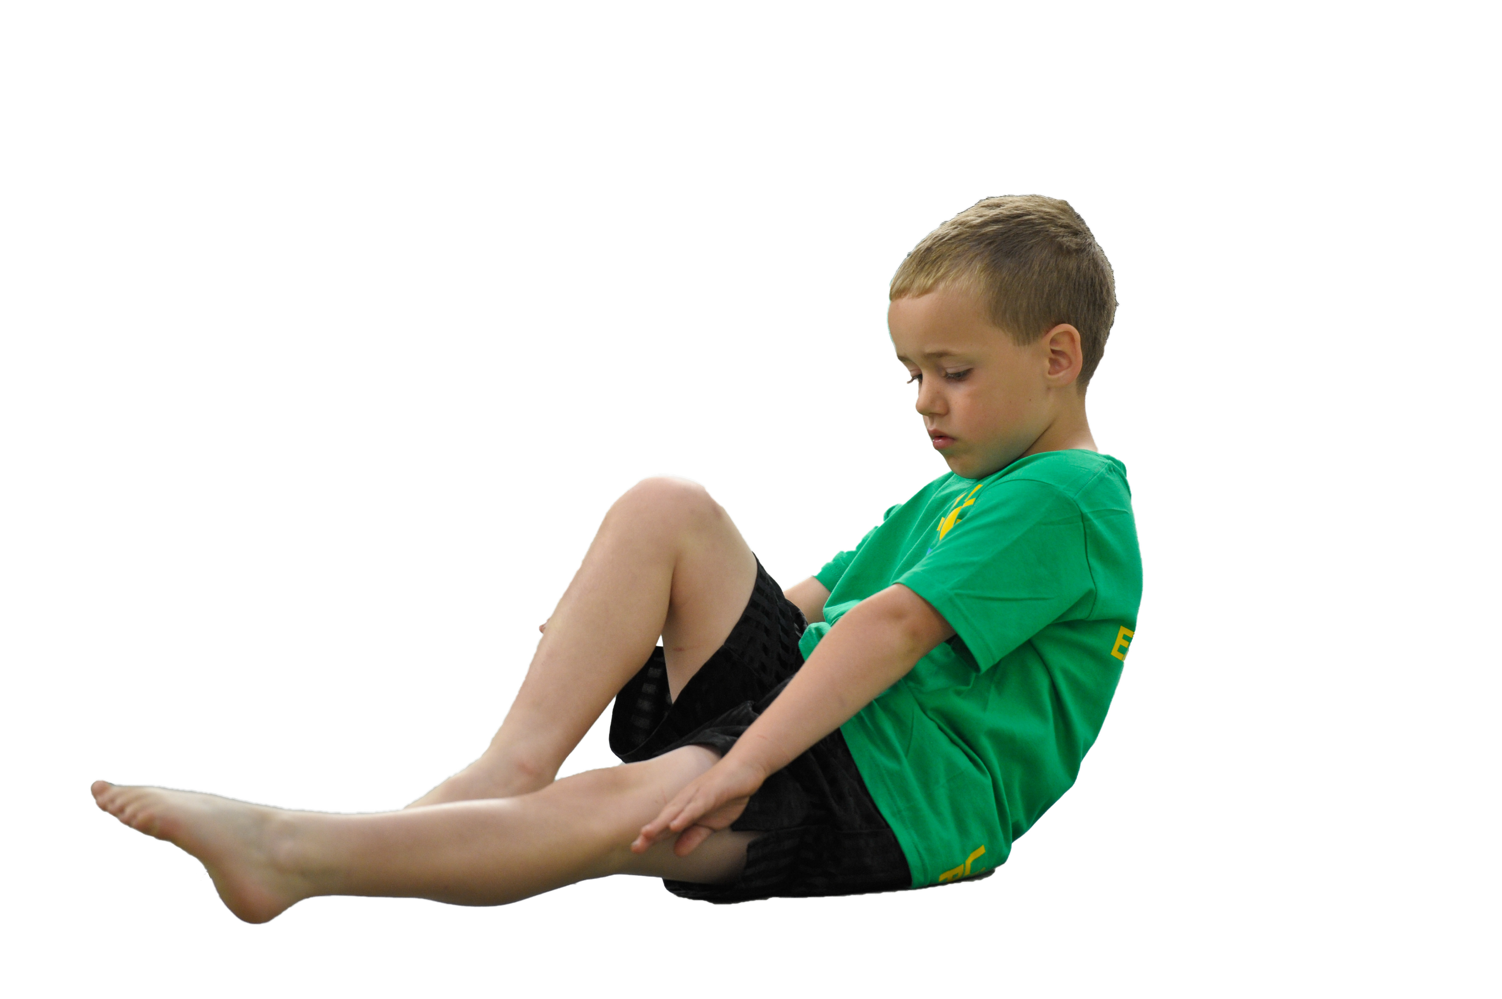
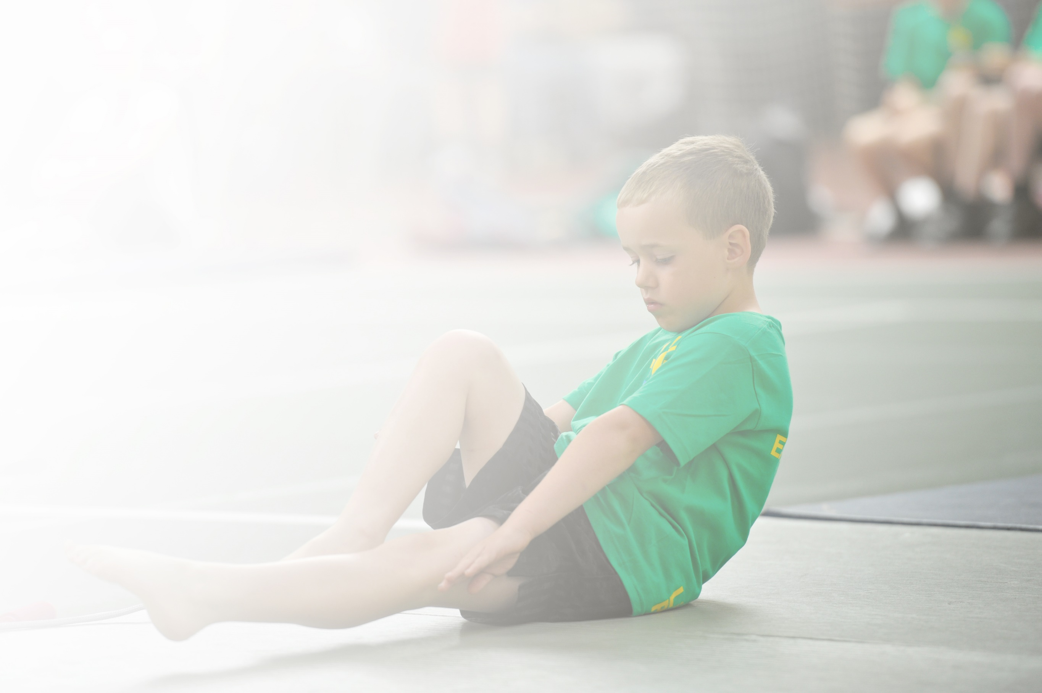
Schools must use the funding to make additional and sustainable improvements to the quality of Physical Education, Sport and Physical Activity (PESPA) they offer. This means that you should use the Primary PE and Sport Premium to:

- Develop or add to the PESPA activities that your school already offer
- Build capacity and capability within the school to ensure that improvements made now will benefit pupils joining the school in future years

Please visit gov.uk for the revised DfE guidance including the 5 key indicators across which schools should demonstrate an improvement. This document will help you to review your provision and to report
your spend. DfE encourages schools to use this template as an effective way of meeting the reporting requirements of the Primary PE and Sport Premium.

We recommend you start by reflecting on the impact of current provision and reviewing the previous
spend. Under the Ofsted Schools Inspection Framework, inspectors will assess how effectively leaders use the Primary PE and Sport Premium and measure its impact on outcomes for pupils, and how effectively governors hold them to account for this.

Schools are required to publish details of how they spend this funding as well as on the impact it has on pupils’ PE and sport participation and attainment by the end of the summer term or by 31 July 2019 at the
latest.
We recommend regularly updating the table and publishing it
on your website throughout the year, as evidence of your
ongoing review into how you are using the money to
secure maximum, sustainable impact. To see an
example of how to complete the table please
click HERE.

Support for review and reflection - considering the 5 key indicators from DfE, what development needs are a priority for your setting and your students now and why? Use the space below to reflect on previous spend, identify current need and priorities for the future.

Key achievements to date: | Areas for further improvement and baseline evidence of need:
More children have an increased sense of worth in physical activity and sport and are proud of their achievements.  Children have developed a healthy competitive spirit.  Increased uptake and enjoyment of competitive sport.  All children are beginning to experience a broader range of sports.  Regular engagement of all pupils in daily sport and physical activity. | Continue to provide broader experiences.  Increase the competitive element for KS1 children.  Increase the opportunities for intra competitions.  Introduce a PE profile for each child.  Continue to develop children’s leadership, organisation, resilience, initiative and communication skills- (Skills Builder)

Meeting national curriculum requirements for swimming and water safety | Please complete all of the below:
What percentage of your current Year 6 cohort swim competently, confidently and proficiently over a distance of at least 25 metres?  N.B. Even though your children may swim in another year please report on their attainment on leaving  primary school. | 50%
What percentage of your current Year 6 cohort use a range of strokes effectively [for example, front crawl, backstroke and breaststroke]? | 67%
What percentage of your current Year 6 cohort perform safe self-rescue in different water-based situations? | 0 %
Schools can choose to use the Primary PE and Sport Premium to provide additional provision for swimming but this must be for activity over and above the national curriculum requirements. Have you used it in this way? | Yes. We will use some sports premium money to provide additional lessons for children not able to swim 25m.

Action Plan and Budget Tracking
Capture your intended annual spend against the 5 key indicators. Clarify the success criteria and evidence of impact that you intend to measure to evaluate for students today and for the future.

Academic Year: 2019-20 | Total fund allocated: £ | Date Updated: September 2019
Key indicator 1: The engagement of all pupils in regular physical activity – Chief Medical Officer guidelines recommend that primary school children undertake at least 30 minutes of physical activity a day in school |  |  |  | Percentage of total allocation:
 |  |  |  | %
School focus with clarity on intended impact on pupils: | Actions to achieve: | Funding allocated: | Evidence and impact: | Sustainability and suggested next steps:
Continue to encourage inactive pupils to be more active so they understand its importance. | Audit pupils to identify physical activity levels and know which sports they would like to try.  Audit opportunities for physical activity within other curriculum areas and introduce ways of being more active regularly. | £500 | Children recognise the importance of physical activity and are keen to be active as much as possible. | Carry out the audit twice a year to track activity levels and determine focus groups.
Key indicator 2: The profile of PESSPA being raised across the school as a tool for whole school improvement |  |  |  | Percentage of total allocation:
 |  |  |  | %
School focus with clarity on intended impact on pupils: | Actions to achieve: | Funding allocated: | Evidence and impact: | Sustainability and suggested next steps:
All children to see sport and physical activity as a regular part of leading a healthy lifestyle. | Continue to highlight sporting achievements in assemblies.  Maintain a sports board in school with children’s out of school sports listed as well as outcomes of competition.  Continue to participate in as many competitions as possible.  All children to have a PE passport documenting their fitness, achievements and competitions entered.  All children to have regular brain breaks- ‘Go Noodle’.  Through ‘Skills Builder’, children learn key skills in a systematic way of- team work, aiming high, listening, leadership, staying positive and creativity. | £2000  £900 | All children will be able to talk about a favourite sport and find their ‘thing’. They will be proud and keen to share their successes.  Resilience and skills in handling competition and games on the playground will be better managed.

Key indicator 3: Increased confidence, knowledge and skills of all staff in teaching PE and sport |  |  |  | Percentage of total allocation:
 |  |  |  | %
School focus with clarity on intended  impact on pupils: | Actions to achieve: | Funding  allocated: | Evidence and impact: | Sustainability and suggested  next steps:
Staff continue to be upskilled in teaching PE to allow for a sustainable model to be maintained. | Staff work alongside PE coaches and specialists.  KH to take the lead PE role.  Staff to discuss assessment of PE in staff meetings.  KH to take a coaching course.  Release the PE lead to attend PE meetings and events. | £5,085  £1,750 | Knowledge and skills will be maintained within school without relying on PE coaches. | KH to train staff.
Key indicator 4: Broader experience of a range of sports and activities offered to all pupils |  |  |  | Percentage of total allocation:
 |  |  |  | %
School focus with clarity on intended  impact on pupils: | Actions to achieve: | Funding  allocated: | Evidence and impact: | Sustainability and suggested  next steps:
Additional achievements:  Continue to provide a full range of experiences at playtimes to get children active. | .Introduce as many different activity ideas at playtimes as possible.  Increase the intra competitions to lunch times led by staff.  Re-model the playground with improved sports equipment. | £2600 | Children will be excited about being active.  All children, especially KS1 will be involved in competitive sport and learn how to handle the notion of competition.
Key indicator 5: Increased participation in competitive sport |  |  |  | Percentage of total allocation:
 |  |  |  | %
School focus with clarity on intended  impact on pupils: | Actions to achieve: | Funding  allocated: | Evidence and impact: | Sustainability and suggested  next steps:
Ensure that all pupils continue to have opportunities to enter competitions. | KH to have an afternoon a week to prepare children for competitions.  Discuss issue of few KS1 competitions with sports cluster and forge links with other schools.  Increase the intra competitions to lunch times led by staff.  Continue to be part of the sports cluster. | See above  £600  £2,350 | Children have a better understanding of working in a team.  Manage winning and losing equally. | Continue the links with other schools to a regular timetable.  Continue to employ KH to lead PE.

