**FAIRBURN COMMUNITY PRIMARY SCHOOL   
BEHAVIOUR MANAGEMENT POLICY**

*Fairburn children behave well and show respect, understanding and a sense of responsibility towards others.*

*Fairburn respects the diversity of all individuals and seeks to ensure that all members of its community are included, valued and happy.*

**Rationale**

We value good relationships between adults and pupils, which we believe are vital to the development of self-esteem as well as self-discipline. Developing such relationships relies on the good behaviour of our pupils, which we feel should be encouraged and rewarded. Both school and parents expect the highest standard of behaviour from our pupils and we aim to work together to achieve it. We have school expectations that are understood by all, consistently applied and aim to promote the pupils learning behaviour. We believe that pupils should be treated fairly, consistently and with their individual needs accounted for, therefore being made to feel valued within the school.

At Fairburn Community Primary School we have the duty to teach those values, attitudes and skills which foster mutual respect and caring in our pupils. We use whole school assemblies, class circle times, SEAL, and PHSE & Citizenship lessons to discuss such values. We believe that through rewarding and reinforcing examples of good behaviour, pupils’ esteem and self-worth is increased.

We are a Restorative Practise School so all relationships, both staff, pupils and parents are repaired using a restorative approach.

A high emphasis is placed on courtesy, manners and respect between members of the school community. Sanctions are managed swiftly, consistently and appropriately with all necessary parties informed as required.

**Roles within our school**

**Pupils**

* Listen carefully to each other and allow others to speak without interruption
* Follow instructions given by an adult
* Respond politely to adults and other children when addressed
* Display good table manners at lunchtime
* Take responsibility for their own behaviour
* Be kind and respectful to others
* Always try their hardest and do their best
* Move quietly and sensibly around the school
* Take care of their own property and school property; and value other people’s belongings
* Be on time for a teaching session and have the required equipment

**Staff**

* Listen to children when they speak
* Provide opportunities for children to explain their actions before responding-*‘What has just* *happened?’*- **not** *‘Why did you do that?’* (A Restorative Approach)
* Be punctual for lessons and duties
* Address pupils by name whenever possible
* Set an example for pupils to follow in their behaviour towards both adults and pupils
* Provide a safe environment free from disruption, bullying, aggression or harassment
* Deal with a difficult situation quickly and efficiently before moving on, ensuring the child feels that it has been dealt with
* Follow the agreed process for using the Behaviour board as set out in this policy and in both classrooms
* Treat all pupils fairly and with respect
* Foster positive, respectful and supportive relationships with the pupils in school
* Develop positive relationships with parents/carers to develop a shared approach
* Ensure records of serious behaviour are recorded in the Behaviour log in the school office

**Governors**

* Agree the guidelines set down in the Behaviour Policy and regularly and review their effectiveness
* Support the Head teacher and staff in carrying out these guidelines fairly and consistently
* Support the differentiation of policy and practice on any grounds necessary i.e. origin,

culture, religion, gender, disability or sexuality

**Head teacher**

* Promote good behaviour and respect
* Listen to pupils
* Ensure each child is treated fairly and with respect
* Model positive, social behaviour, setting a good example to staff and pupils
* The Head teacher will ensure that support and training is in place for staff to manage challenging

behaviour- annually at least

* Give effective reprimands and reminders of good behaviour
* Work closely with parents to help improve a child's behaviour
* Comply with LA regulations regarding the use of force to control or restrain pupils
* Work with outside agencies to support parents and children to manage behaviour
* Exclude a pupil from school for a fixed term, or permanently in accordance with LA guidelines
* Notify Governors of any intended exclusions, following LA procedure
* Ensure records of 'serious' behaviour are maintained

**Good Behaviour**

At Fairburn Community Primary School, all staff are committed to promoting and rewarding good behaviour. We believe that the most effective way of achieving our aims and expectations is to praise and encourage positive behaviour and to motivate pupils in realising that good behaviour is valued. Opportunities within school to do this are through-

* Teacher’s Certificate Awards
* Teaching by example
* Shark Awards
* Positive praise
* Stickers
* Treats
* Allocation of responsibilities
* Raise self- esteem through teaching independent and self- reliance
* Listening
* Positive feedback to using ‘Marvellous Me’
* Gold Awards

Certificates are awarded for children following school rules; working hard and for demonstrating skills builder skills.

A ‘Gold Board’ cited near the behaviour board, celebrates all those children who consistently behave well and follow the schools rules. This behaviour is rewarded in our Gold Assembly with a special certificate and a treat. If a child appears on the Gold Board three times within a term, they can receive a gold badge.

**Corrective actions / Inappropriate Behaviour**

Despite all the efforts of the school, inappropriate behaviour will sometimes occur. In such times

these issues need to be considered and explored.

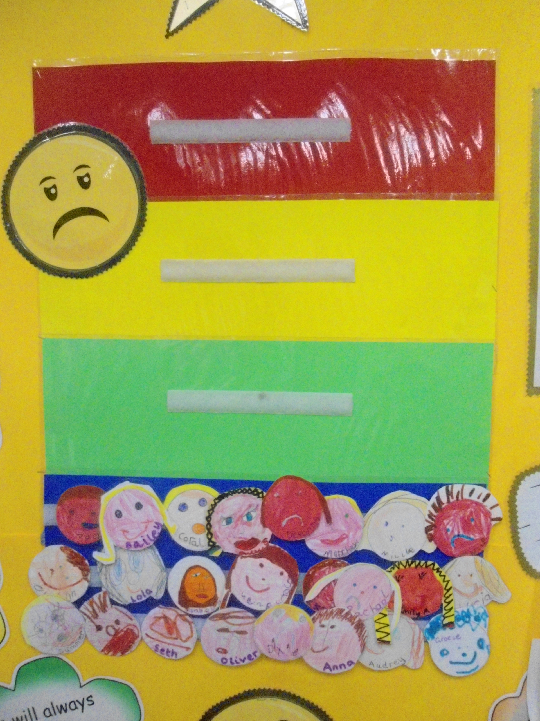**Behaviour Boards**

Following advice and training from our local EMS, we operate behaviour boards in school. They are situated in each classroom, the resource room and in the Hall. Children are reminded of our school rules (See Appendix) weekly. Every opportunity is taken to identify children who follow them. All children are placed in Blue where they remain unless their behaviour breaks one of our school rules. When this happens, the following process will happen-

**Step 1**: The child is given a warning that their behaviour is unacceptable in terms that they are making an

*unwise choice* about how they are acting.

**Step 2**: If the child continues, the staff member will place their name in the Green section of the board.

This means that the child must miss 5 minutes of the next playtime. (3 minutes for Foundation

Stage children)

**Step 3**: As soon as the member of staff can see that the child has corrected their behaviour, they **MUST**

move the child’s name back into the Blue section. This **MUST** as quickly as possible and not be left

there for the rest of the lesson.

**Step 4:** If the child repeats unacceptable behaviour, then repeat step three. The staff member may choose

to leave the child in the Blue section slightly longer to ensure they have settled back to their

lesson.

**Step 5**: However, if the child chooses not to correct their behaviour following step 3 or 4, they should be

given a warning that they will be placed in the Yellow section of the board. This means they will be

asked to take themselves out of the lesson/room for a short period. This must only be a **minute or**

**two** before the staff member goes to talk to them. Children should **not** be left unsupervised for any

length of time.

**Step 6**: The Red section of the board is only to be used if a child uses unacceptable language (Swear words)

or physically hurts another person. In such instances, the child is immediately sent to the Head

teacher/ senior member of staff and their parents are contacted. A meeting then follows to discuss

the child’s behaviour.

**Persistent low level behaviour**

If a child is moving up and down the behaviour board regularly over a period of a week, a meeting will be called with parents to try and determine what may be causing this behaviour. A behaviour log may be temporarily implemented and regular parent meetings to feedback and monitor the situation.

Other actions maybe-

* Close liaison with Parents/Carers
* Referral to the School SENCO
* Referral to school PSA
* An individual behaviour plan
* Focussed social skills programmes
* Home /school achievement book
* Referrals to outside agencies

**Extreme Behaviour**

In extreme cases, it may be deemed appropriate by the Head teacher to issue the following sanctions:

* Exclusion – fixed or permanent (in line with statutory regulations)

**PE lessons outside**

Instances of unacceptable behaviour maybe managed slightly differently in outside PE lessons. If behaviour is still unacceptable after a warning, the child will be asked to sit out of the lesson, in sight of the teacher, for a short period of time. They should join back in as soon as possible however. If they still choose to make an incorrect choice and their behaviour is dangerous to other pupils, the teacher may send in a Green card for a member of staff to come outside and either talk to the child or bring them inside.

**SEN**

Pupils who are referred to the Special Educational Needs Co-ordinator (SENCO) are monitored in accordance with the SEN Code of Practice.

**Restorative Circle Meetings**

These are called with a group of children/ adults/ parents & children after a significant event has occurred which has caused upset. They must be chaired by a trained member of staff. They can only happen if all parties involved with the issue agree to the meeting happening and both parties must be spoken to separately beforehand. Once the meeting takes place, the restorative questions, as written on the wall in the Resource Room, must be followed. The process is intended to help both parties to understand the others perspective and to heal a rift amicably.

## Dealing with and managing bullying

Bullying is behaviour by an individual or group, repeated over time, that intentionally hurts another individual or group either physically or emotionally.

* Bullying is not to be mistaken for the occasional ‘falling-out’ with peers, but may take many forms – physical, verbal, gesture, extortion, and exclusion, any of which can make a bullied child feel anxious and distressed.
* Bullying can adversely affect a child’s ability to concentrate, and reach their potential. Such behaviour can take place in the classroom, but is more likely to occur at break and lunchtimes.
* It is important that staff are available at all of these times to monitor behaviour and to be available should a child need support.
* It is important to remind pupils that they will be listened to if they feel they are being bullied. Immediate support should be offered to the child who should be reassured that they are not to blame for what has happened to them.
* It is ***essential*** to involve parents when their child has been a victim of bullying and to ensure they are aware how the matter is being handled and to enable them to give their child support at home.

If it transpires that bullying behaviour has taken place then the parents of the child who has bullied will be invited to discuss the matter with the Head teacher. Sanctions should be agreed between both parties and a plan drawn up which makes future expectations of behaviour clear to everyone.

* If a child or a parent feels that their child has been bullied it must be recorded in the behaviour log in the Office even if a discussion reveals that the child had not been bullied.

**Related policies**

SEN

Exclusions

Anti-bullying

Restrictive Physical Intervention Guidance

**Approved Date:** November 2017

**Review date:** November 2021

We will always be polite and listen to each other.

We will always follow instructions.

We will be kind to everyone.

We will always speak nicely to each other so no one gets upset.

We will always put our hands up and take turns.

These rules will continue to be reviewed annually